TOP SECRET  
  
10.30.2015  
  
1900 hrs.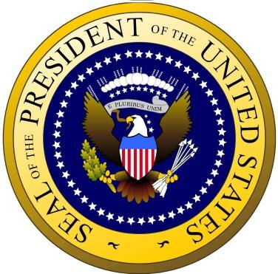

Intelligence intercepts of the official transcripts from the meeting between Vladimir Putin and Bashar Al-Assad on 20th October 2015 reveal strong concerns about the rising western support to the Armed Syrian Rebel Groups going against the Assad Regime and hint towards a plan to start eliminating all such western backed Rebel Groups. Intercepts also point towards a potential arms deal between Russia and Syria supplying Assad with surface to air missiles, anti-ballistic missiles, self-propelled guns and armored vehicles. Intelligence also reports that these findings are suggestive of a possible no-fly zone being instituted over Syria in an attempt to “block any further western influence”

